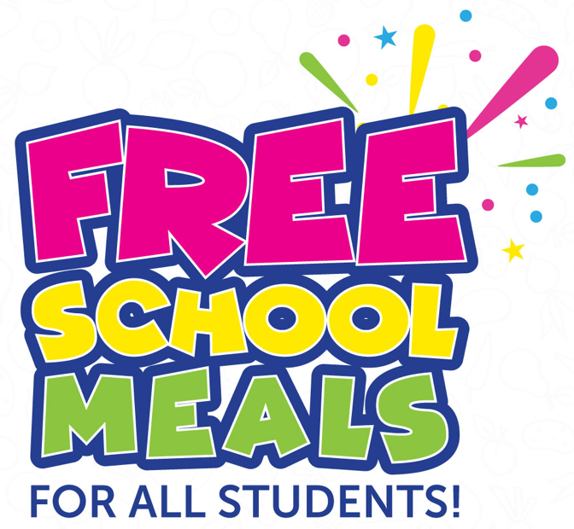
Your School District has implemented the Community Eligibility Program (CEP) throughout the current school year.

WHAT DOES THIS MEAN FOR YOUR CHILD/CHILDREN?
He or she is eligible for FREE BREAKFAST and FREE LUNCH at school during the current school year. Your child/children can participate in school breakfast and lunch without having to pay a fee or submit an application. No further action is required by you.

ALL MEALS MEET FEDERAL AND STATE GUIDELINES.
All meals will meet federal and state guidelines. Students must take 3 of the 4 items offered at breakfast, and 1
of those items must be a 1/2 cup fruit. At lunch, students must take 3 of the 5 items offered and 1 of those
items must be a 1/2 cup fruit or vegetable. We are excited to introduce the “Pack and Carry” Option! Students that still want to pack a lunch may do so and also still participate in school lunch. We offer fresh fruits (apple, banana, orange, etc.), fresh veggies (baby carrots or tossed salad for example) and a choice of milk. for students to take as they go through the serving lines. These items, along with the packed items, will help complete their lunch at no additional cost to you.

ARE ALA CARTE ITEMS INCLUDED?
Students who wish to purchase an extra entree, one of our snack options, or just milk must pay for them.
This program does not apply to ala carte items.

CONVENIENTLY MANAGE STUDENT ACCOUNTS.
You can add money for your student(s) account to purchase extra meal items or snacks, identify when and
what your child/children are eating, and receive low balance account notice by visiting your online payment
Service. Please Visit https://www.schoolcafe.com/ to create or login to your child’s account.

Rachel Vargeson, Director of Food & Nutrition
Northern Potter School District
rvargeson@northernpottersd.org or nothernpotter@thenutritiongroup.biz

