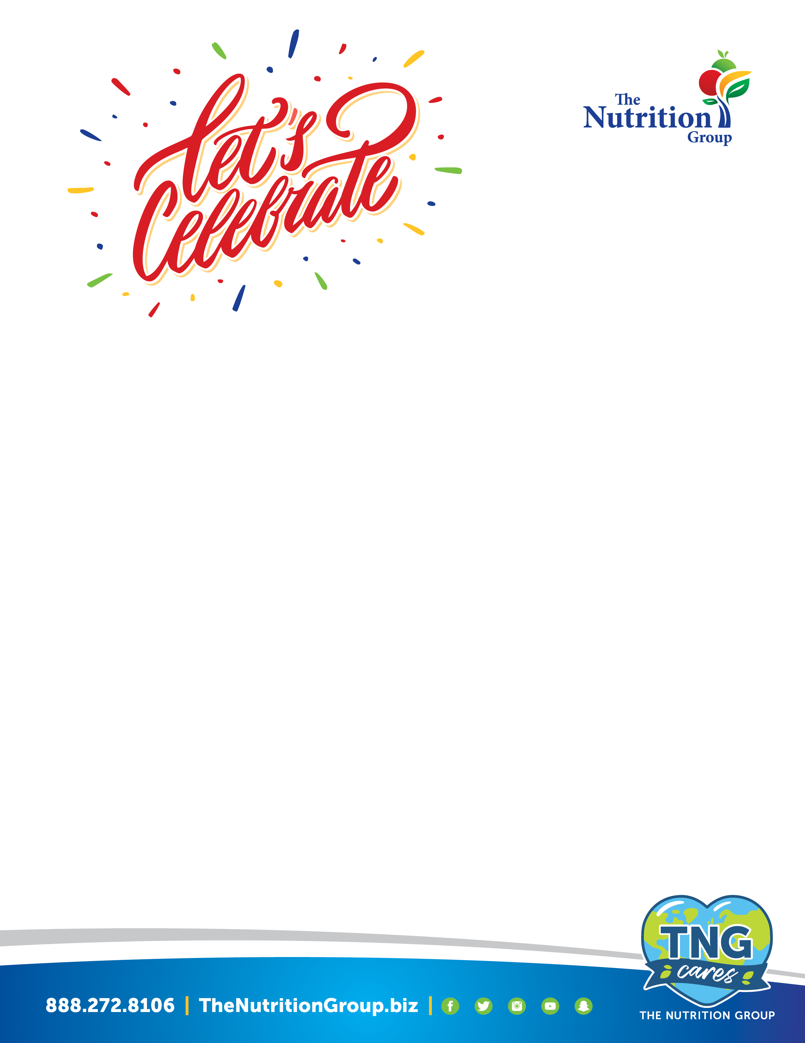

Create Your Very Own

Classroom Celebration!

Student Name: ___________________ Parent Contact: _____________

Teacher:___________________ Delivery Date/Time:_________

Delivery Must be before 2:00pm

Quantity Requested Total $

Fresh Baked Cookie Cake $15.00 each ______________ _________
Fresh Baked cookie cake topped with cool whip and sprinkles
customized to your choice. Serves approximately 20

Cookie Message: _______________________________________

Hershey’s Ice Cream Cups $1.25 each ______________ ________
Individual Fruit or Veggie Snack (Please circle) $0.90 each ______________ ________
Bagged apple slices -or- baby carrots with ranch dip

White Milk or 4oz Juice (Please circle) $0.65 each _______________ _________

All menu items listed above meet Smart Snack requirements

Party plans must pre-approved by the student’s teacher and placed one week prior to event date.

Please return order form with payment to your student's building foodservice department.

Checks may be written out: NPSD CAFÉTERIA FUND

Questions: Call Rachel Vargeson, Director of Food and Nutrition 814-331-3906

